Undoubtedly, Natural Language Processing (NLP) research has taken enormous leaps after being relatively stationary for a couple of years. Firstly, Google’s Bidirectional Encoder Representations from Transformer (BERT) [1] becoming the highlight by the end of 2018 for achieving state-of-the-art performance in many NLP tasks and not much later, OpenAI’s GPT-2 stealing the thunder by promising even more astonishing results which reportedly rendering it too dangerous to publish! Considering the time frame and the players behind these publications, it takes no effort to realize that there is a lot of activity in the space at the moment.
That being said, we will focus on BERT for this post and attempt to have a small piece of this pie by extracting pre-trained contextualized word embeddings like ELMo [3].
To give you a brief outline, I will first give a little bit of background context, then a take a high-level overview of BERT’s architecture, and lastly jump into the code while explaining some tricky parts here and there.
Just for more convenience, I will be using Google’s Colab for the coding but the same code can as well run on your local environment without many modifications.
If you came just for the coding part, skip to the “BERT Word Embedding Extraction” section. Find the finished notebook code here.

Word Embeddings
To start off, embeddings are simply (moderately) low dimensional representations of a point in a higher dimensional vector space. In the same manner, word embeddings are dense vector representations of words in lower dimensional space. The first, word embedding model utilizing neural networks was published in 2013 [4] by research at Google. Since then, word embeddings are encountered in almost every NLP model used in practice today. Of course, the reason for such mass adoption is quite frankly their effectiveness. By translating a word to an embedding it becomes possible to model the semantic importance of a word in a numeric form and thus perform mathematical operations on it. To make this more clear I will give you the most common example that you can find in the context of word embeddings
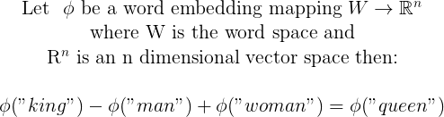
When this was first possible by the word2vec model it was an amazing breakthrough. From there, many more advanced models surfaced which not only captured a static semantic meaning but also a contextualized meaning. For instance, consider the two sentences below:
I like apples.
I like Apple macbooks
Note that the word apple has a different semantic meaning in each sentence. Now with a contextualized language model, the embedding of the word apple would have a different vector representation which makes it even more powerful for NLP tasks.

Transformers
To be frank, much of the progress in the NLP space can be attributed to the advancements of general deep learning research. More particularly, Google (again!) presented a novel neural network architecture called a transformer in a seminal paper [5] which had many benefits over the conventional sequential models (LSTM, RNN, GRU etc). Advantages included but were not limited to, the more effective modeling of long term dependencies among tokens in a temporal sequence, and the more efficient training of the model in general by eliminating the sequential dependency on previous tokens.
In a nutshell, a transformer is an encoder-decoder architecture model which uses attention mechanisms to forward a more complete picture of the whole sequence to the decoder at once rather than sequentially as illustrated in the figures below.
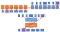
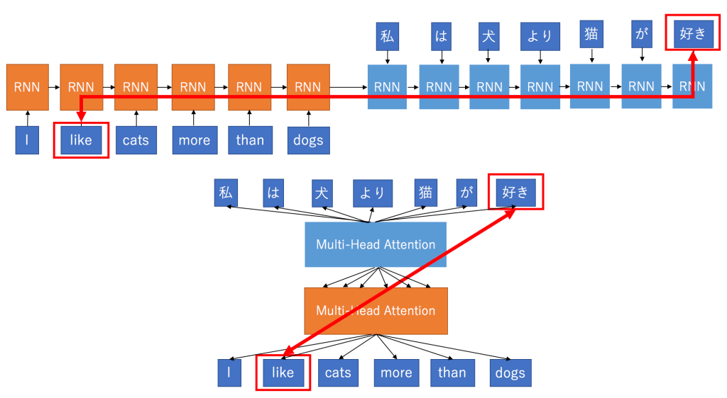
Source: http://mlexplained.com/2017/12/29/attention-is-all-you-need-explained/

OpenAI’s GPT was the first to create a transformer based language model with fine tuning but to be more precise, it was only using the decoder of the transformer. Therefore, making the language modeling uni-directional. The technical reason for dropping out the encoder was that language modeling would become a trivial task as the word to be predicted could have ultimately seen itself.

Bidirectional Encoder Representations from Transformer (BERT)
By now, the name of the model should probably make more sense and give you a rough idea of what it is. BERT brought everything together to build a bidirectional transformer-based language model using encoders rather than decoders! To overcome the “see itself” issue, the guys at Google had an ingenious idea. They employed masked language modeling. In other words, they hid 15% of the words and used their position information to infer them. Finally, they also mixed it up a little bit to make the learning process more effective.
Although this methodology had a negative impact on convergence time, it outperformed state-of-the-art models even before convergence which sealed the success of the model.
Normally, BERT represents a general language modeling which supports transfer learning and fine-tuning on specific tasks, however, in this post we will only touch the feature extraction side of BERT by just obtaining ELMo-like word embeddings from it, using Keras and TensorFlow.
https://towardsdatascience.com/nlp-extract-contextualized-word-embeddings-from-bert-keras-tf-67ef29f60a7b

